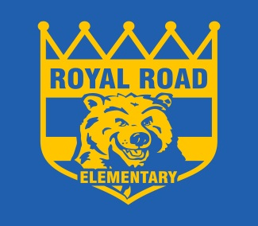

To Learn, To Grow, To Lead

Dear Royal Road Families,
On Friday, June 24th, we are kicking off the summer with a full breakfast for all our students. It will be pancakes, bacon, and juice. There is no cost to our Royal Road Families.
To ensure that we order enough breakfast for everyone and that we do not order too much, and waste food. Please fill out the form below and return it to your child’s teacher no later than Friday, June 10th. Unfortunately, due to the necessity of having to order ahead of time we cannot accept any late orders.
If you have more than one child at Royal Road, please fill out the form for each child.
Best Regards,

Ms. Legere
Principal

Student Name:

Classroom Teacher:

- Yes, I would like to have a pancake breakfast

- No, I would not like to have a pancake breakfast

